SIMATS ENGINEERING

ASSESSMENT TOOL 3 – Assignment 2

COURSE NAME: STATISTICS WITH R PROGRAMMING COURSE CODE: ITA04

COURSE OUTCOME COVERED

CO3: Construct and manipulate data frames using reshaping, merging, and file I/O operations in R to prepare structured datasets for analysis. (BL3, BL5)

Assessment Tool Weightage: 20%

QUESTIONS: 5 Total Marks: 100

Annexure Assignment 2

Code of Conduct:

I A.Yaswanth (192324179) certify that this submission is my original work and that I have adhered to the guidelines specified for this assessment.
I understand that any violation of academic integrity rules will result in disciplinary action.

Signature of the student:



Assignment 2:
- Generate 5 Questions for your Capstone Project module

- Apply the formulae and use the relevant graph to visualize it

- Upload the file in Github link

- Save the 5 Questions and Gihub link in the Excell sheet

Answers

Question 1: Association Between Primary Diagnosis and Hospital Readmission

Research Question
Is there a statistically significant association between a patient's primary diagnosis and hospital readmission status?
Objective
To investigate whether hospital readmission patterns differ according to patients' primary diagnosis using the UCI Diabetes 130-US Hospitals dataset [last 5 years].
Variables Used
- Primary Diagnosis (diag_1): The primary diagnosis code recorded for the patient.
- Readmission Status (readmitted): Indicates whether the patient was not readmitted (NO), readmitted within 30 days (<30), or readmitted after 30 days (>30).

For this analysis, <30 and >30 are combined into Readmitted, while NO is classified as Not readmitted.
Statistical Test: Chi-square Test of Independence
Why is this test best?
The Chi-square test of independence is appropriate because primary diagnosis and readmission status are categorical variables. It determines whether a statistically significant association exists between these variables.
Hypotheses
- Null hypothesis (H₀): Primary diagnosis and readmission status are independent.
- Alternative hypothesis (H₁): Primary diagnosis and readmission status are associated.
Formula and Explanation
Chi-square test statistic:
Chi-square = Σ [(O − E)² / E]
Expected frequency:
Expected frequency = (Row Total × Column Total) / Grand Total
Where:
- O = Observed frequency from the dataset.
- E = Expected frequency under the null hypothesis.
- R = Row total.
- C = Column total.
- N = Grand total.
- χ² = Chi-square test statistic.

R Code

if (!requireNamespace("ggplot2", quietly = TRUE)) {
install.packages("ggplot2")
}

if (!requireNamespace("scales", quietly = TRUE)) {
install.packages("scales")
}

library(ggplot2)
library(scales)

# Load the dataset by selecting the CSV file
file_path <- file.choose()

df <- read.csv(
file_path,
stringsAsFactors = FALSE
)

# Display dataset dimensions
cat("Dataset dimensions:\n")
print(dim(df))

# Check required columns
required_columns <- c("diag_1", "readmitted")

if (!all(required_columns %in% names(df))) {
stop("The selected CSV does not contain diag_1 and readmitted columns.")
}

# Remove missing and invalid records
d <- df[
!is.na(df$diag_1) &
df$diag_1 != "?" &
df$readmitted %in% c("NO", "<30", ">30"),
]

# Combine readmission categories
d$readmission <- ifelse(
d$readmitted == "NO",
"Not readmitted",
"Readmitted"
)

# Find the 10 most frequent primary diagnosis codes
diagnosis_counts <- sort(
table(d$diag_1),
decreasing = TRUE
)

top_diagnoses <- head(names(diagnosis_counts), 10)

# Group all remaining diagnosis codes as Other
d$diagnosis <- ifelse(
d$diag_1 %in% top_diagnoses,
d$diag_1,
"Other"
)

# Create observed frequency table
observed <- table(
d$diagnosis,
d$readmission
)

cat("\nOBSERVED FREQUENCIES:\n")
print(observed)

# Calculate expected frequencies
expected <- outer(
rowSums(observed),
colSums(observed)
) / sum(observed)

cat("\nEXPECTED FREQUENCIES:\n")
print(round(expected, 2))

# Calculate Chi-square contributions
contributions <- (observed - expected)^2 / expected

cat("\nCHI-SQUARE CONTRIBUTIONS:\n")
print(round(contributions, 4))

# Perform the Chi-square test
if (any(expected < 5)) {
test_result <- chisq.test(
observed,
simulate.p.value = TRUE,
B = 10000
)
} else {
test_result <- chisq.test(
observed,
correct = FALSE
)
}

cat("\nCHI-SQUARE TEST RESULT:\n")
print(test_result)

cat("\nP-VALUE:\n")
print(test_result$p.value)

# Interpret the actual p-value
if (test_result$p.value < 0.05) {
cat(
"\nInterpretation: There is statistically significant",
"evidence of an association between primary diagnosis",
"and readmission status.\n"
)
} else {
cat(
"\nInterpretation: There is insufficient statistical",
"evidence of an association between primary diagnosis",
"and readmission status.\n"
)
}

# Calculate readmission proportions for the chart
plot_data <- as.data.frame(
prop.table(observed, margin = 1)
)

names(plot_data) <- c(
"Diagnosis",
"Readmission",
"Proportion"
)

# Create the 100% stacked bar chart
ggplot(
plot_data,
aes(
x = Diagnosis,
y = Proportion,
fill = Readmission
)
) +
geom_col() +
scale_y_continuous(
labels = percent,
limits = c(0, 1)
) +
labs(
title = "Readmission by Primary Diagnosis",
subtitle = paste(
"Chi-square p-value =",
signif(test_result$p.value, 5)
),
x = "Primary Diagnosis Code",
y = "Percentage of Encounters",
fill = "Readmission Status"
) +
theme_minimal() +
theme(
axis.text.x = element_text(
angle = 45,
hjust = 1
),
legend.position = "bottom"
)

Output:
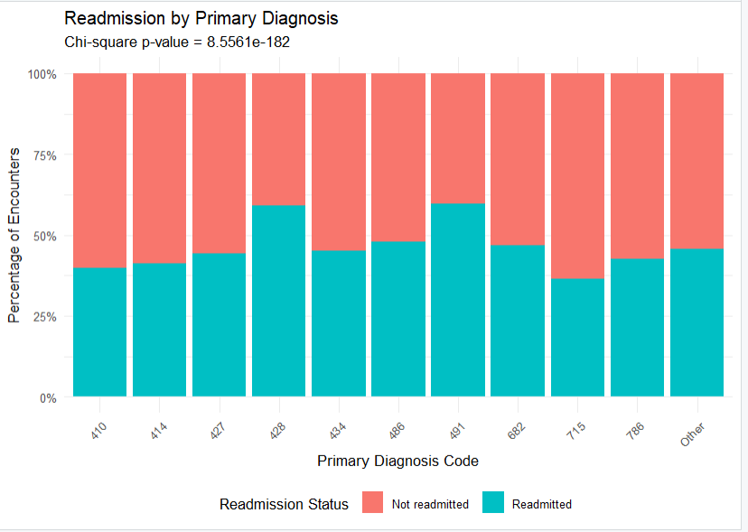

Graph for Visualization
A 100% stacked bar chart is best for this module because it compares readmission percentages across different primary diagnosis codes.

Question 2: Previous Inpatient Visits and Hospital Readmission

Research Question
Do previous inpatient visit counts differ significantly between patients who were readmitted and those who were not readmitted?
Objective
To analyze whether the number of previous inpatient visits differs between readmitted and non-readmitted patients using the UCI Diabetes 130-US Hospitals dataset Last 5 years.
Variables
- Independent grouping variable: Readmission status (readmitted)
- Dependent variable: Number of previous inpatient visits (number_inpatient)
- Groups: Readmitted and Not readmitted
The values <30 and >30 are combined into Readmitted, while NO represents Not readmitted.
Statistical Test
Wilcoxon Rank-Sum Test (Mann–Whitney U Test)
Why:
This test is used to compare the distributions of previous inpatient visit counts between two independent groups. It is suitable because visit counts are often skewed and may contain many zero values.
Hypotheses
- Null hypothesis (H₀): The distributions of previous inpatient visit counts are the same for readmitted and non-readmitted patients.
- Alternative hypothesis (H₁): The distributions of previous inpatient visit counts differ between the two groups.
Formula
The Wilcoxon rank-sum statistic is:
W = Sum of ranks for observations in the first group
Ranks are assigned to all observations after combining both groups in ascending order. Equal values receive average ranks.

R Code

if (!requireNamespace("ggplot2", quietly = TRUE)) {
install.packages("ggplot2")
}
library(ggplot2)

# Load the dataset
file_path <- file.choose()
df <- read.csv(file_path, stringsAsFactors = FALSE)

# Check required columns
if (!all(c("number_inpatient", "readmitted") %in% names(df))) {
stop("Required columns are missing from the dataset.")
}

# Select valid observations
d <- df[
!is.na(df$number_inpatient) &
df$readmitted %in% c("NO", "<30", ">30"),
]

d$number_inpatient <- as.numeric(d$number_inpatient)
d <- d[!is.na(d$number_inpatient), ]

# Combine readmission categories
d$readmission <- ifelse(
d$readmitted == "NO",
"Not readmitted",
"Readmitted"
)

d$readmission <- factor(
d$readmission,
levels = c("Not readmitted", "Readmitted")
)

# Display descriptive statistics
cat("Summary of Previous Inpatient Visits:\n")

print(
aggregate(
number_inpatient ~ readmission,
data = d,
FUN = function(x) {
c(
Count = length(x),
Median = median(x),
Mean = round(mean(x), 2),
IQR = IQR(x)
)
}
)
)

# Perform Wilcoxon rank-sum test
test_result <- wilcox.test(
number_inpatient ~ readmission,
data = d,
exact = FALSE
)

cat("\nWilcoxon Rank-Sum Test Result:\n")
print(test_result)

cat("\nP-value:\n")
print(test_result$p.value)

# Interpret the result
if (test_result$p.value < 0.05) {
cat(
"\nInterpretation: Previous inpatient visit counts differ significantly between the two groups.\n"
)
} else {
cat(
"\nInterpretation: There is insufficient evidence of a significant difference between the two groups.\n"
)
}

# Create box plot
ggplot(
d,
aes(x = readmission, y = number_inpatient,
fill = readmission)
) +
geom_boxplot(outlier.alpha = 0.25) +
labs(
title = "Previous Inpatient Visits by Readmission Status",
x = "Readmission Status",
y = "Number of Previous Inpatient Visits",
fill = "Readmission Status"
) +
theme_minimal() +
theme(legend.position = "none")

Output:
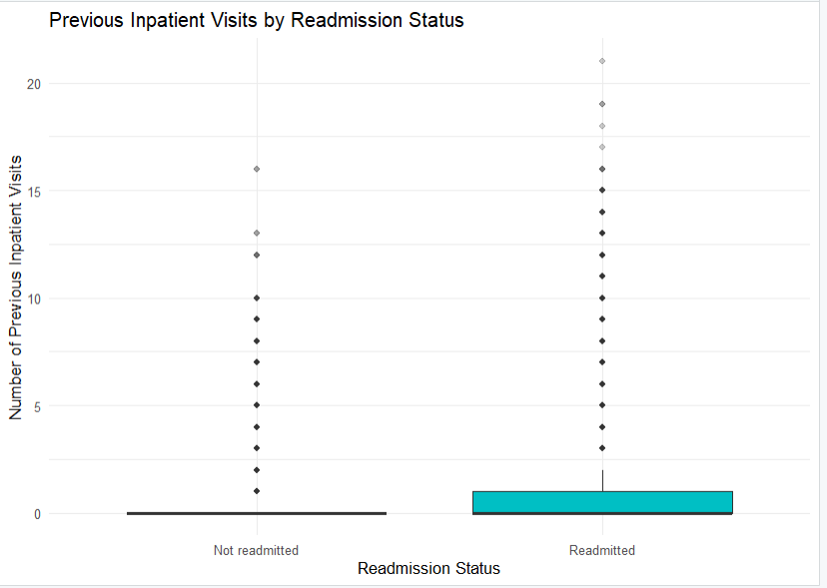

Graph for Visualization
Graph Type: Box Plot
A box plot is best for this module because it compares previous inpatient visits between readmitted and non-readmitted patients and highlights the distribution and outliers.

Question 3: Relationship Between Previous Inpatient Visits and Length of Hospital Stay

Research Question
Is there a significant relationship between the number of previous inpatient visits and the length of the current hospital stay?
Objective
To examine the relationship between previous inpatient visits and the number of days patients stay in the hospital using the UCI Diabetes 130-US Hospitals dataset (1999–2008).
Variables
- Variable 1: Number of previous inpatient visits (number_inpatient)
- Variable 2: Length of hospital stay in days (time_in_hospital)
Statistical Test
Spearman's Rank Correlation Test
This test measures the strength and direction of a relationship between two variables without requiring them to follow a normal distribution.
Hypotheses
- Null hypothesis (H₀): There is no significant relationship between previous inpatient visits and length of hospital stay.
- Alternative hypothesis (H₁): There is a significant relationship between previous inpatient visits and length of hospital stay.
Formula
Spearman's Rank Correlation Coefficient:
rs = 1 − [6 × Σ(dᵢ²)] / [n × (n² − 1)]
Where:
- rs = Spearman's rank correlation coefficient
- dᵢ = Difference between the ranks of each pair
- n = Number of observations

R Code

if (!requireNamespace("ggplot2", quietly = TRUE)) {
install.packages("ggplot2")
}
library(ggplot2)

# Load the dataset
file_path <- file.choose()
df <- read.csv(file_path, stringsAsFactors = FALSE)

# Check required columns
if (!all(c("number_inpatient", "time_in_hospital") %in% names(df))) {
stop("Required columns are missing from the dataset.")
}

# Select valid observations
d <- df[
!is.na(df$number_inpatient) &
!is.na(df$time_in_hospital),
]

d$number_inpatient <- as.numeric(d$number_inpatient)
d$time_in_hospital <- as.numeric(d$time_in_hospital)

d <- d[
!is.na(d$number_inpatient) &
!is.na(d$time_in_hospital),
]

# Display summary
cat("Summary of Previous Inpatient Visits:\n")
print(summary(d$number_inpatient))

cat("\nSummary of Length of Hospital Stay:\n")
print(summary(d$time_in_hospital))

# Perform Spearman's rank correlation test
test_result <- cor.test(
d$number_inpatient,
d$time_in_hospital,
method = "spearman",
exact = FALSE
)

cat("\nSpearman Rank Correlation Test:\n")
print(test_result)

cat("\nCorrelation Coefficient:\n")
print(unname(test_result$estimate))

cat("\nP-value:\n")
print(test_result$p.value)

# Interpret the result
if (test_result$p.value < 0.05) {
cat(
"\nInterpretation: There is a statistically significant relationship between previous inpatient visits and length of hospital stay.\n"
)
} else {
cat(
"\nInterpretation: There is insufficient evidence of a significant relationship between previous inpatient visits and length of hospital stay.\n"
)
}

# Create scatter plot
ggplot(
d,
aes(
x = number_inpatient,
y = time_in_hospital
)
) +
geom_jitter(
alpha = 0.15,
width = 0.15,
height = 0.15
) +
geom_smooth(
method = "loess",
se = FALSE
) +
labs(
title = "Previous Inpatient Visits vs Length of Hospital Stay",
x = "Number of Previous Inpatient Visits",
y = "Length of Hospital Stay (Days)"
) +
theme_minimal()

Output:
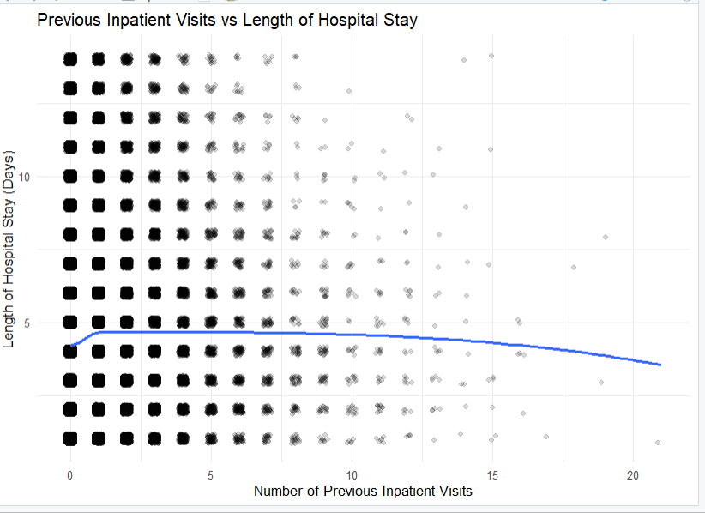

Visualization
Graph Type: Scatter Plot

A scatter plot is best for this module because it shows the relationship between previous inpatient visits and the length of the current hospital stay.
Question 4: Length of Hospital Stay and Hospital Readmission
Research Question
Does the average length of hospital stay differ significantly between readmitted and non-readmitted patients?
Objective
To compare the average length of hospital stay between readmitted and non-readmitted patients using the UCI Diabetes 130-US Hospitals dataset (last 5 years).
Variables
- Grouping variable: Readmission status (readmitted)
- Dependent variable: Length of hospital stay (time_in_hospital)
- Groups: Readmitted and Not readmitted
Statistical Test
Welch's Two-Sample t-Test
Why:
This test compares the average hospital stay of two independent groups without assuming that their variances are equal.
Hypotheses
- Null hypothesis (H₀): The average length of hospital stay is equal for both groups.
- Alternative hypothesis (H₁): The average length of hospital stay differs between the two groups.
Formula
Welch's t-statistic:
t = (Mean₁ − Mean₂) / √[(s₁²/n₁) + (s₂²/n₂)]
Where:
- Mean₁ and Mean₂ = Average hospital stay for each group
- s₁ and s₂ = Standard deviations of the groups
- n₁ and n₂ = Number of patients in each group

R Code

if (!requireNamespace("ggplot2", quietly = TRUE)) {
install.packages("ggplot2")
}
library(ggplot2)

# Load the dataset
file_path <- file.choose()
df <- read.csv(file_path, stringsAsFactors = FALSE)

# Check required columns
if (!all(c("time_in_hospital", "readmitted") %in% names(df))) {
stop("Required columns are missing from the dataset.")
}

# Keep valid records
d <- df[
!is.na(df$time_in_hospital) &
df$readmitted %in% c("NO", "<30", ">30"),
]

d$time_in_hospital <- as.numeric(d$time_in_hospital)
d <- d[!is.na(d$time_in_hospital), ]

# Combine readmission categories
d$readmission <- ifelse(
d$readmitted == "NO",
"Not readmitted",
"Readmitted"
)

d$readmission <- factor(
d$readmission,
levels = c("Not readmitted", "Readmitted")
)

# Display summary statistics
cat("Length of Hospital Stay by Readmission Status:\n")

print(
aggregate(
time_in_hospital ~ readmission,
data = d,
FUN = function(x) {
c(
Count = length(x),
Mean = round(mean(x), 2),
Median = median(x),
SD = round(sd(x), 2)
)
}
)
)

# Perform Welch's two-sample t-test
test_result <- t.test(
time_in_hospital ~ readmission,
data = d,
var.equal = FALSE
)

cat("\nWelch's Two-Sample t-Test Result:\n")
print(test_result)

cat("\nP-value:\n")
print(test_result$p.value)

# Interpret the result
if (test_result$p.value < 0.05) {
cat(
"\nInterpretation: The average length of hospital stay differs significantly between the two groups.\n"
)
} else {
cat(
"\nInterpretation: There is insufficient evidence of a significant difference in average hospital stay.\n"
)
}

# Create violin plot with an internal box plot
p <- ggplot(
d,
aes(x = readmission, y = time_in_hospital,
fill = readmission)
) +
geom_violin(trim = TRUE, alpha = 0.7) +
geom_boxplot(width = 0.12, fill = "white",
outlier.shape = NA) +
labs(
title = "Length of Hospital Stay by Readmission Status",
x = "Readmission Status",
y = "Length of Hospital Stay (Days)"
) +
theme_minimal() +
theme(legend.position = "none")

print(p)

Output:
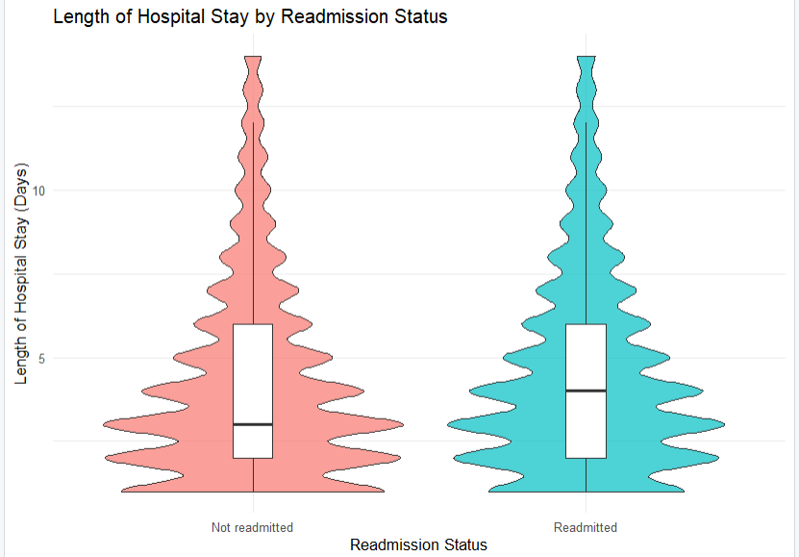

Graph for Visualization
Graph Type: Violin Plot
A violin plot is best for this module because it compares the distribution and density of hospital stay durations between readmitted and non-readmitted patients.
Question 5: Relationship Between Primary Diagnosis and Length of Hospital Stay
Research Question
Does the length of hospital stay differ based on the patient's primary diagnosis?
Objective
To examine whether the number of days patients stay in the hospital varies according to their primary diagnosis using the UCI Diabetes 130-US Hospitals dataset (1999–2008).
Variables
- Independent variable: Primary diagnosis (diag_1)
- Dependent variable: Length of hospital stay (time_in_hospital)
Statistical Test
Kruskal–Wallis Test
Why:
This test compares hospital stay durations across three or more independent diagnosis groups. It is useful when the data may not follow a normal distribution.
Hypotheses
- Null hypothesis (H₀): The distribution of hospital stay duration is the same across the diagnosis groups.
- Alternative hypothesis (H₁): At least one diagnosis group has a different distribution of hospital stay duration.
Formula
H = [12 / (N × (N + 1))] × Σ(Rᵢ² / nᵢ) − 3 × (N + 1)
Where:
- H = Kruskal–Wallis test statistic
- N = Total number of observations
- Rᵢ = Sum of ranks for each diagnosis group
- nᵢ = Number of observations in each diagnosis group
R Code

library(ggplot2)

# Load dataset
file_path <- file.choose()
df <- read.csv(file_path, stringsAsFactors = FALSE)

# Check required columns
if (!all(c("diag_1", "time_in_hospital") %in% names(df))) {
stop("Required columns are missing from the dataset.")
}

# Prepare data
d <- df[
!is.na(df$diag_1) &
df$diag_1 != "?" &
!is.na(df$time_in_hospital),
]

d$time_in_hospital <- as.numeric(d$time_in_hospital)
d <- d[!is.na(d$time_in_hospital), ]

# Select the 10 most common diagnosis codes
diagnosis_counts <- sort(table(d$diag_1), decreasing = TRUE)
top_diagnoses <- head(names(diagnosis_counts), 10)

d <- d[d$diag_1 %in% top_diagnoses, ]
d$diagnosis <- factor(d$diag_1)

# Display summary statistics
cat("Hospital Stay by Primary Diagnosis:\n")

print(
aggregate(
time_in_hospital ~ diagnosis,
data = d,
FUN = function(x) {
c(
Count = length(x),
Median = median(x),
Mean = round(mean(x), 2)
)
}
)
)

# Perform Kruskal-Wallis test
test_result <- kruskal.test(
time_in_hospital ~ diagnosis,
data = d
)

cat("\nKruskal-Wallis Test Result:\n")
print(test_result)

cat("\nP-value:\n")
print(test_result$p.value)

# Interpret the result
if (test_result$p.value < 0.05) {
cat(
"\nInterpretation: Hospital stay duration differs significantly across at least some diagnosis groups.\n"
)
} else {
cat(
"\nInterpretation: There is insufficient evidence of a difference in hospital stay duration across diagnosis groups.\n"
)
}

# Create box plot
p <- ggplot(
d,
aes(x = diagnosis, y = time_in_hospital)
) +
geom_boxplot(outlier.alpha = 0.25) +
labs(
title = "Length of Hospital Stay by Primary Diagnosis",
x = "Primary Diagnosis Code",
y = "Length of Hospital Stay (Days)"
) +
theme_minimal() +
theme(
axis.text.x = element_text(angle = 45, hjust = 1)
)

print(p)

Output:
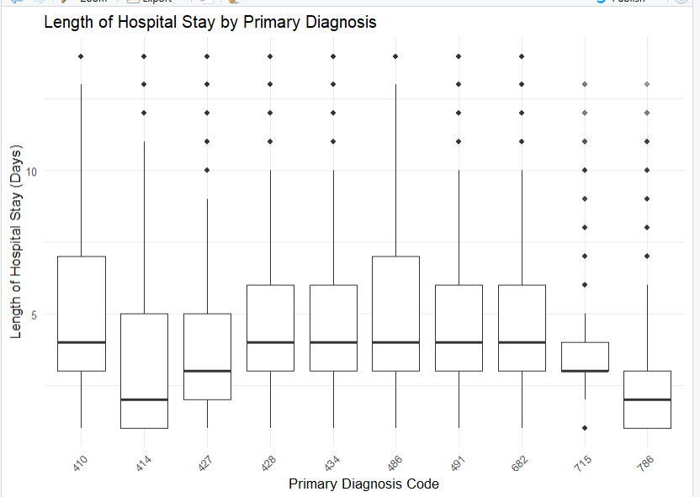

Visualization and Interpretation
Graph Type: Box Plot
A box plot is best for this module because it compares the distribution of hospital stay durations across different primary diagnosis codes.

